libusbK Driver Installation

# Installation

Download the free software Zadig, available in the following link: <https://zadig.akeo.ie/>.

1. Connect Windows PC/Laptop to the evaluation board using the provided USB cable.
2. Open Zadig and click on Options
3. Check the option List All Devices from the drop-down
4. Uncheck Ignore Hubs or Composite Parents as shown in Figure 1.

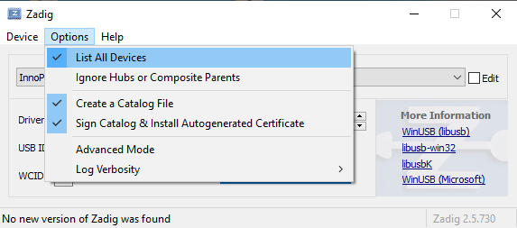

Figure 1: Listing devices in Zadig

To establish communication with Talaria TWO module via the FTDI device on the InnoPhase Evaluation Board, the Talaria TWO USB driver must be libusbK. In case the current driver is not libusbK, use the drop-down menu to select libusbK and click on Replace Driver which will update the drivers to libusbK.

Figure 2: Updating Talaria TWO USB driver to libusbK

To check if the libusbK driver is successfully installed, Go to Device Manager. Expand the libusbK USB Devices and the InnoPhase T2 Evaluation Board (Composite Parent) gets listed.

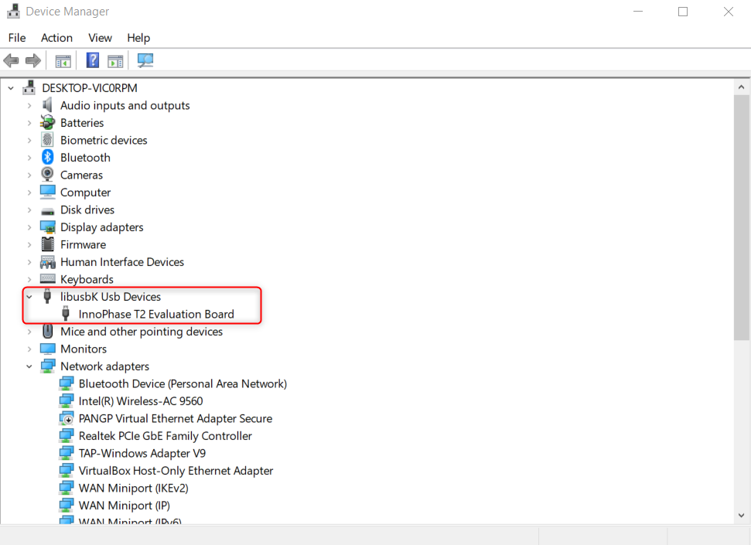

Figure 3: Device Manager-libusbK USB Devices

# Uninstall Instructions

To uninstall libusbK and retrieve COM ports, follow the following steps:

1. Go to Device Manager. Expand the libusbK USB Devices and right click on the InnoPhase T2 Evaluation Board (Composite Parent). Click on Update Driver as shown in Figure 22.

Figure 22: Device Manager

1. On the new window, click on Let me pick from a list of available drivers on my computer option and click on Next.

Figure 23: Update Devices

1. Select USB Composite Device and install the same for reinstalling COM posts.

Figure 24: Select the device driver